ASSEMBLY POINT LOCATION: COCKCROFT BUILDING
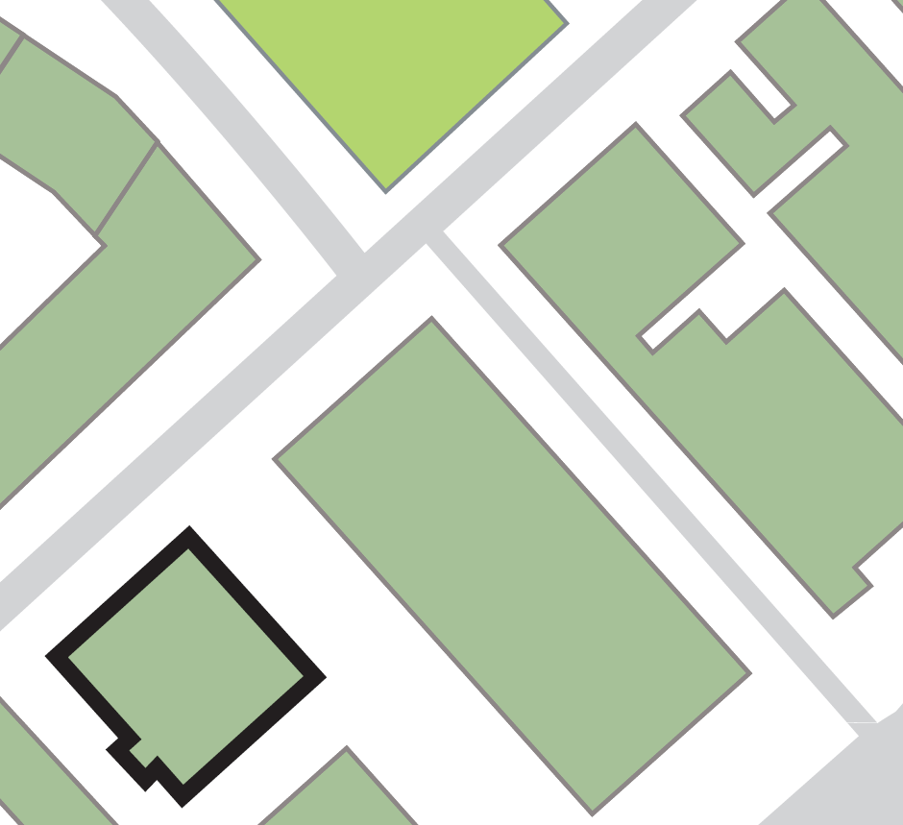

COCKCROFT
BUILDING
Ramsden Building
Sir Patrick Stewart Building
Queen Street Building
Joseph Priestley Building

Assembly point 12 (area below Queen Street and Sir Patrick Stewart buildings)
Exiting the building by its: -
Main exit opposite Joseph Priestley Building.
Exit adjacent to Ramsden Building.

