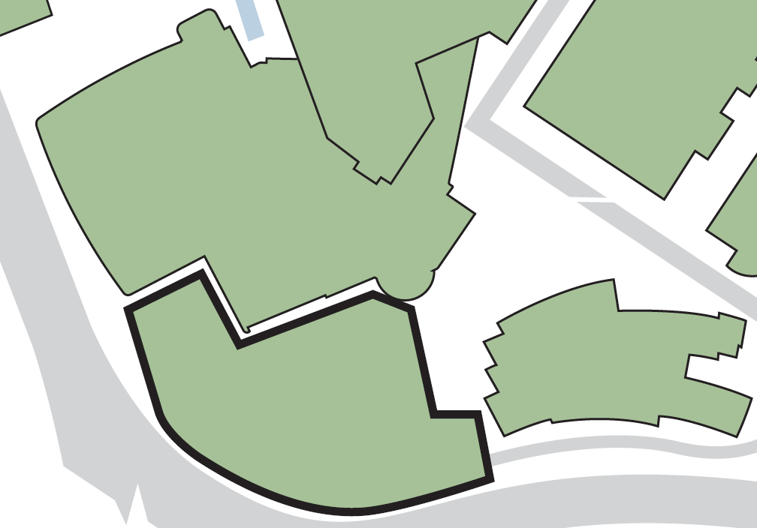

**Laura Annie Willson Building**

**Fire exit from staircase onto Queensgate**

**5**

**If evacuating the building by:**

**Fire exits from level 2**

**6**

**Fire exits from level 3 into area alongside Student Central**

**7**

**If evacuating the building by:**

**Assembly point 5 (Wakefield Road car park)**

**Assembly point 1 (service road at rear of Richard Steinitz Building)**

**1**

**Fire exit from level 5 into Student Central**

**8**

**Fire exits onto Queensgate from OA4/01 and 02 lecture theatres**

**4**

**Fire exit from staircase nearest Richard Steinitz Building**

**3**

**Fire exit from rear of OA4/01 lecture theatre**

**2**

**Assembly point 14 (adjacent to Laura Annie Willson Building)**

**If evacuating the building by:**

**1**

**Its main exit and fire exit from atrium at level 4**

**8**

**7**

**6**

**5**

**4**

**3**

**2**

**Schwann Building**

**OASTLER BUILDING**

**Richard Steinitz Building**

**Student Central**

**BUILDING ASSEMBLY POINT LOCATIONS – OASTLER BUILDING**