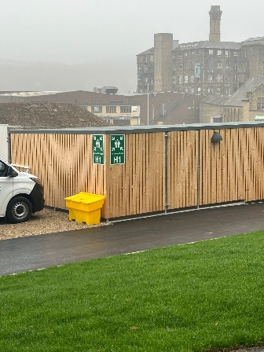

**When evacuating the building, all persons exiting the building should go to Assembly point H1 at the rear of the building**

**BUILDING ASSEMBLY POINT – DAPHNE STEELE BUILDING**

