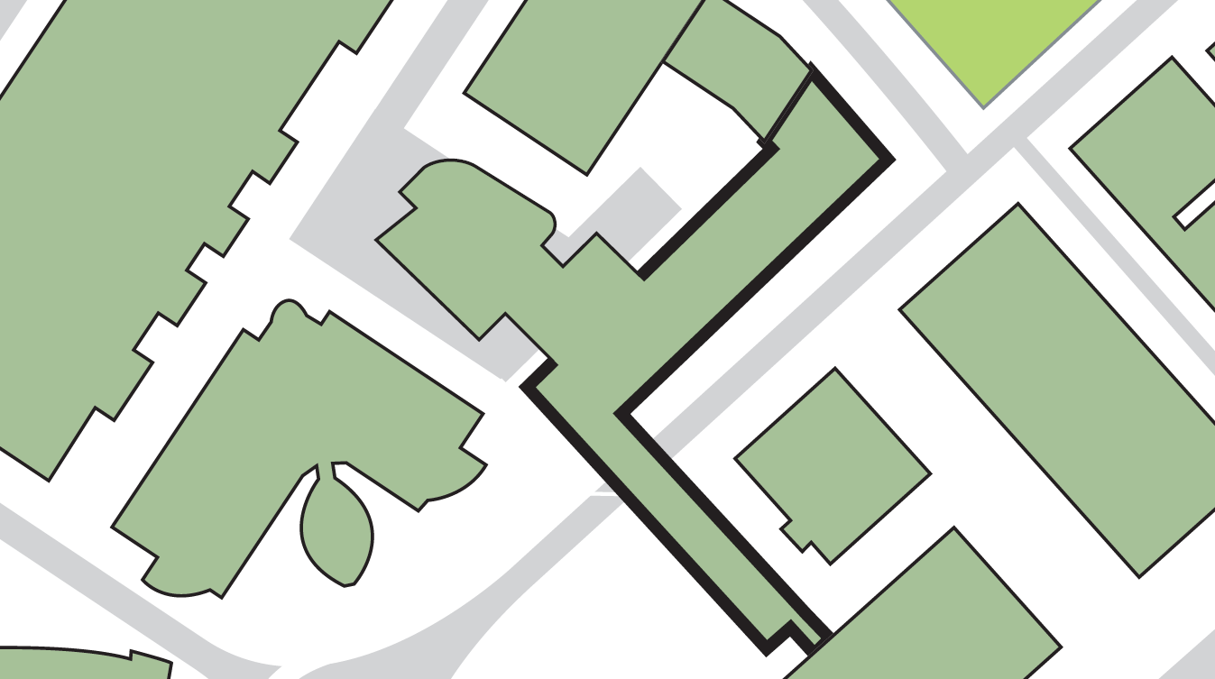

**2**

**Either exit from the main atrium area**

**If evacuating the building by:**

**Harold Wilson Building**

**Joseph Priestley (East) Building**

**Cockcroft Building**

**4**

**6**

**5**

**2**

**2**

**3**

**1**

**JOSEPH PRIESTLEY (SOUTH) BUILDING**

**Joseph Priestley (West) Building**

**Ramsden Building**

**Sir Patrick Stewart Building**

**Laura Annie Willson Building**

**Exit from staircase opposite St Paul’s Hall**

**Fire exit onto St Paul’s Street**

**Fire exit adjacent to Journalism and Media Building**

**6**

**5**

**4**

**Fire exit from the Chemical Engineering laboratory**

**3**

**Assembly point 14 (adjacent to Laura Annie Willson Building)**

**Assembly point 12 (adjacent to Sir Patrick Stewart Building and Queen Street Building)**

**If evacuating the building by:**

**1**

**Main exit onto Rifle Street**

**BUILDING ASSEMBLY POINTS - JOSEPH PRIESTLEY (SOUTH) BUILDING**