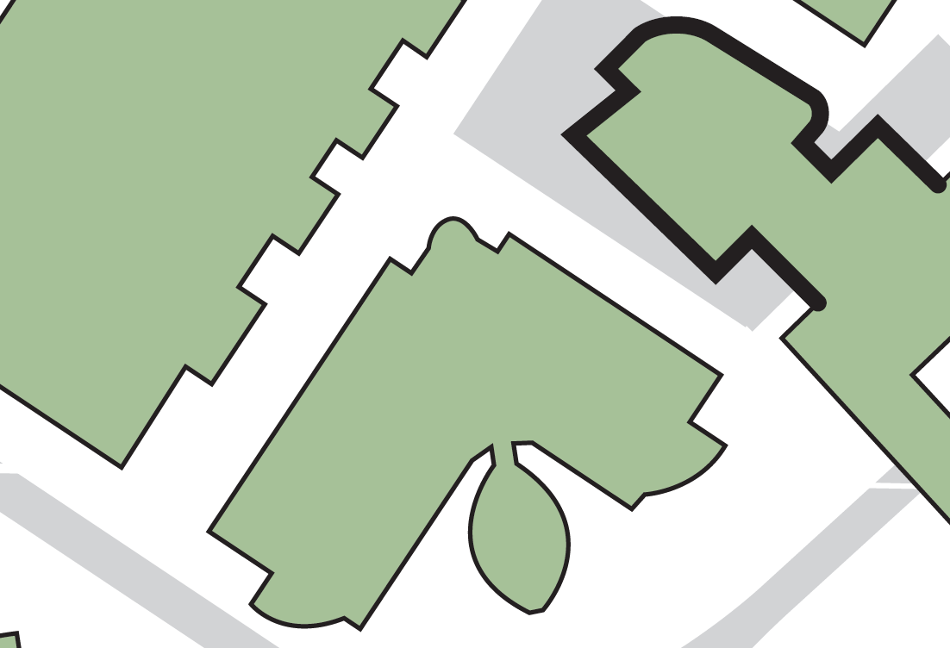

**Harold Wilson Building**

**JOSEPH PRIESTLEY (EAST) BUILDING**

**2**

**1**

**1**

**Laura Annie Willson Building**

**The fire exit staircase**

**Either exit from the main atrium area**

**2**

**1**

**If evacuating the building by:**

**Assembly point 14 (adjacent to Laura Annie Willson Building)**

**BUILDING ASSEMBLY POINT**

**JOSEPH PRIESTLEY (EAST) BUILDING**