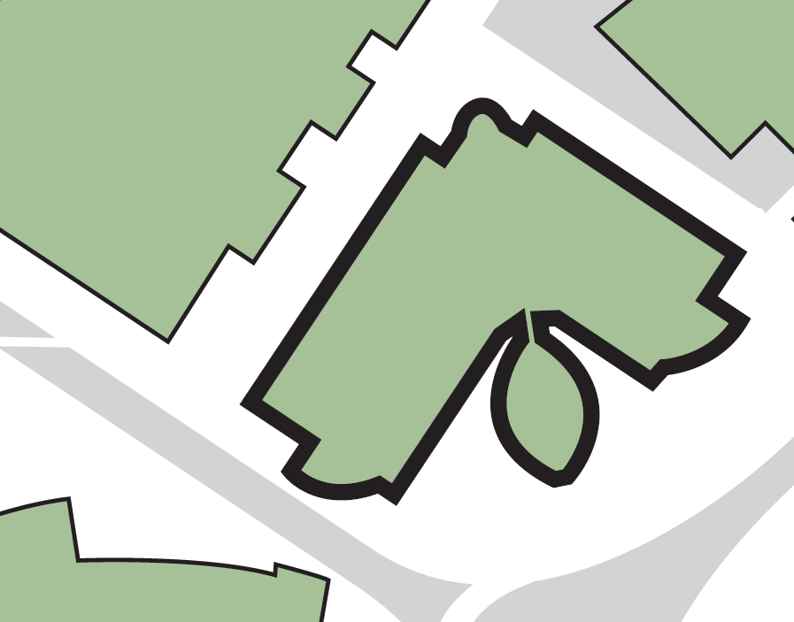

**Exits adjacent to University Reception and security control hub**

**4**

**Fire exits from staircase adjacent to Joseph Priestley East Building**

**3**

**Exits from the bottom of the central spiral staircase**

**Evacuating the building by:**

**4**

**Fire exit from bottom of T4 corridor**

**2**

**1**

**Fire exits from staircase adjacent to Richard Steinitz Building**

**Assembly point 14 (adjacent to Laura Annie Willson Building)**

**Harold Wilson BUILDING**

**2**

**4**

**1**

**3**

**Richard Steinitz Building**

**Laura Annie Willson Building**

**Joseph Priestley East Building**

**ASSEMBLY POINT LOCATION – HAROLD WILSON BUILDING**