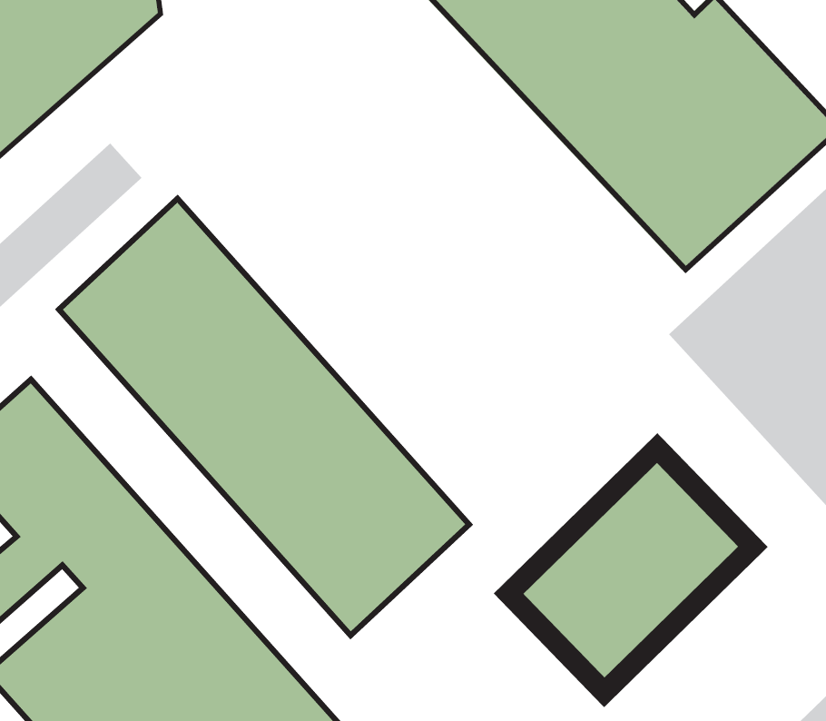

**SOVEREIGN DESIGN HOUSE**

**4**

**Exit from roof top area**

**Fire exit from café area**

**Its main exit**

**4**

**3**

**2**

**Fire exits from the basement exhibition spaces**

**1**

**3**

**2**

**1**

**1**

**Barbara Hepworth Building**

**Percy Shaw House**

**Faith Centre**

**Assembly point 4 (grassed area between Barbara Hepworth Building and Sovereign Design House)**

*Version: May 2021*

**If evacuating the building by:**

**BUILDING ASSEMBLY POINT – SOVEREIGN DESIGN HOUSE**