**v**

**1**

**RICHARD STEINITZ BUILDING**

**3**

**2**

**2**

**Laura Annie Willson Building**

**Oastler Building**

**Schwann Building**

**Student Central**

**Harold Wilson Building**

**3**

**2**

**1**

**Assembly point 3 (area between Schwann Building and Laura Annie Willson Building)**

**If evacuating the building by:**

**Fire exits from the stairwells and atrium area nearest university’s main entrance**

**Its main exit**

**Exit and fire exit from the stairwell and the atrium area nearest Oastler Building**

**ASSEMBLY POINT LOCATION – RICHARD STEINITZ BUILDING**

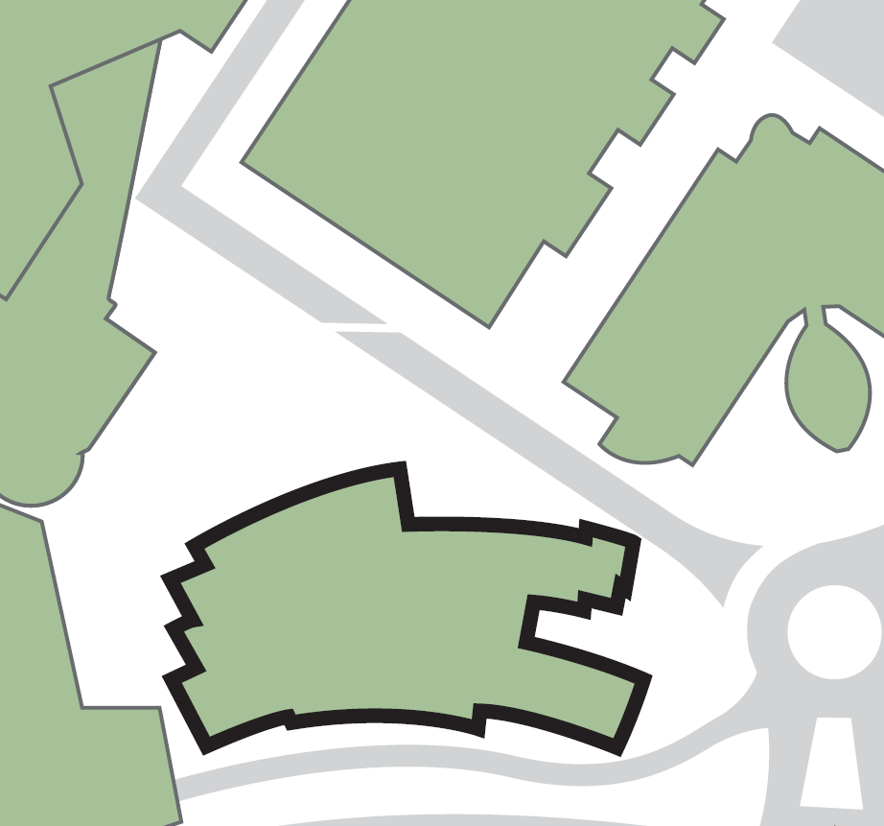****

**Site boundary**

**Oastler Building**

**St Paul’s Hall**