

**Laura Annie Willson Building**

**Fire exits between Starbucks outlet and link to Schwann Building**

**1**

**If evacuating the building by:**

**Assembly point 1 (service road at rear of Richard Steinitz Building)**

**student Central**

**7**

**6**

**5**

**4**

**3**

**3**

**2**

**1**

**Richard Steinitz Building**

**Oastler Building**

**Schwann Building**

**BUILDING ASSEMBLY POINT LOCATIONS – STUDENT CENTRAL**

V

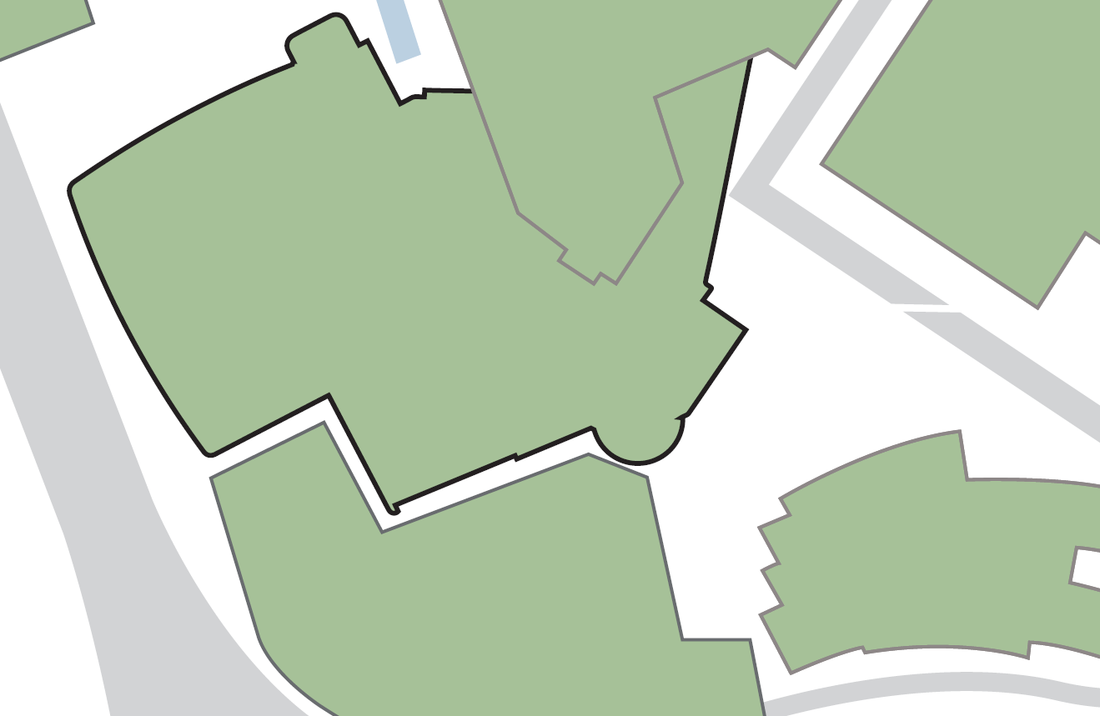

**Its main exit**

**Fire exit staircase nearest the canal**

**Fire exit from staircase nearest Oastler Building**

**2**

**Exit and fire exit gates from ‘Undercroft’ beneath the Sports Hall**

**7**

**6**

**If evacuating the building by:**

**Fire exit from level 3 adjacent to the Sports Hall**

**3**

**Assembly point 14 (adjacent to Laura Annie Willson Building)**

**Fire exit from the Sports Hall**

**5**

**4**

**If evacuating the building by:**

**Assembly point 5 (Wakefield Road car park)**