Office of Health and Safety
Duties, processes and procedures
Building evacuation practices

Contents
1.0 | Purposes of practices | 3
2.0 | Role of Office of Health and Safety | 4
3.0 | Frequency and timing of practices | 4
4.0 | Advanced notification of practices | 5
5.0 | Practices – process flowchart | 6
6.0 | Buildings and lead contacts | 7
7.0 | Non-scheduled evacuations | 8
8.0 | Evacuation reports – document management and retention | 8
 | Appendix A: example log of building evacuation practices | 9
 | Appendix B: example building evacuation report | 10
Document versions
Number | Date | Author | Further information
1.00 | 14/03/2022 | Gary Wood (Health and Safety Adviser)
1.01 | 22/06/2022 |  | Lead representative change - Haslett and Lockside buildings
1.02 | 14/10/2022 |  | Assistant Security Manager added to notification group
1.03 | 21/03/2023 |  | Updated building list and lead contacts
1.04 | 27/07/2023 |  | Updated lead contacts for several buildings.  Removed version footer.
1.05 | 06/10/2023 | Jackie Holmes (Health and Safety Assistant) | Updated lead contacts for several buildings.

1.0 Purpose of practices
The Regulatory Reform (Fire Safety) Order 2005 (RRFSO) does not explicitly require organisations, as ‘responsible persons’ under RRFSO, to undertake evacuation practices at stipulated frequencies. Article 15 of the order does require procedures be in place for events presenting serious or imminent danger to individuals.
Whilst every fire alarm activation requiring resultant evacuation of the building that system serves is not due to events presenting serious or imminent danger, it is still important occupants of buildings respond accordingly to every fire alarm activation.
Below is an extract from section 3.11 of the university’s health and safety policy and the requirements of academic schools and support services in respect of fire safety management:
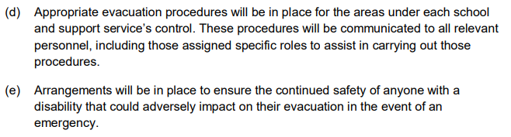
Periodic building evacuation practices therefore present an ideal opportunity to ensure the procedures developed and implemented by the academic school or support service continue to be effective, including through: -
- Those undertaking the roles of evacuation marshals and warden; and
- The responses of those occupying the building at the time of the practice.
These practices are also a mechanism for ensuring the effectiveness of respective building’s fire safety measures where responsibility is vested elsewhere including: -
- Fire alarm system audibility and visibility;
- Adequacy of means of escape;
- The availability and operation of exits and fire exits; and
- Reporting to the university’s control hub should emergency service attendance be required.

2.0 Role of the Office of Health and Safety
The Office of Health and Safety (OHS) acts as the lead coordinator of building evacuation practices across the university’s campus, including the management and retention of the reports arising from individual practices.
The OHS also: -
- Assists in the development, introduction, review and updating of procedures, both general principles and relating to specific buildings;
- Provides guidance and steer through observation during the practice and then in follow, primarily with the lead contacts for each building;
- Liaises with other personnel including colleagues within the Estates and Facilities where practices also target or highlight aspects with building infrastructure (e.g. fire detection and warning systems) or the response of campus support and/or security staff; and
- Assists with any the development and delivery of awareness or similar sessions, these typically being on a building-by-building basis.
3.0 Frequency and timings of practices
Individual practices take place twice-yearly – one during the autumn term, the other during the spring term. This increases the opportunity of students, especially new students in the autumn term, being involved and when the buildings are most likely to have greater occupancy levels and typical day occupant profile.
For academic buildings practices are typically timed to take place at five-past an hour to minimise disruption to individual lectures (i.e. during lecture cross-over periods) but still capture good building occupancy levels and profiles
The following periods and specific days are avoided: -
- Graduation ceremonies; and
- University open days and applicant visit days.

4.0 Advanced notification of practices
The following receive advanced notifications of scheduled practices, no later than end of the working week prior to those practices taking place. The reasoning for the advanced notification is also provided.
Advanced notification recipient | Reasoning for advanced notification
Combined Services Group (CSG) Supervisor | Ensure the re-instatement of systems (e.g. ventilation) interfaced with the respective building’s fire alarm system.  Provide general support (e.g. re-setting of fire alarm systems) if required.
CSG Manager
Security Manager | Ensure awareness for role and support provided during each practice and any subsequent unscheduled fire alarm activations.  Reduce the likelihood of any unwarranted actions during each practice (e.g. contacting the emergency services).
Assistant Security Manager
Control hub (estates.control@hud.ac.uk)
Executive Office Manager, Vice-Chancellor’s Office | To avoid any clash with relevant events or activities involving members of the university’s senior leadership team (e.g. VIP visits, meetings).
Campus Support Manager | To determine the extent of campus support involvement (e.g. taking account of shift patterns, previous opportunities for those on duty, coinciding with other activities having to take priority) and providing familiarisation and reinforcement of role opportunities.
Assistant campus support managers
Disability Office, Student Services (disability@hud.ac.uk) | To bring to the attention of students who’ve declared: -  - Health issues (e.g. anxiety, epilepsy) that can be triggered by exposure to unexpected, loud noises; and  - Interest in being present during a practice as part of securing understanding of the arrangements in place for evacuations as part of their personal learning support plan.

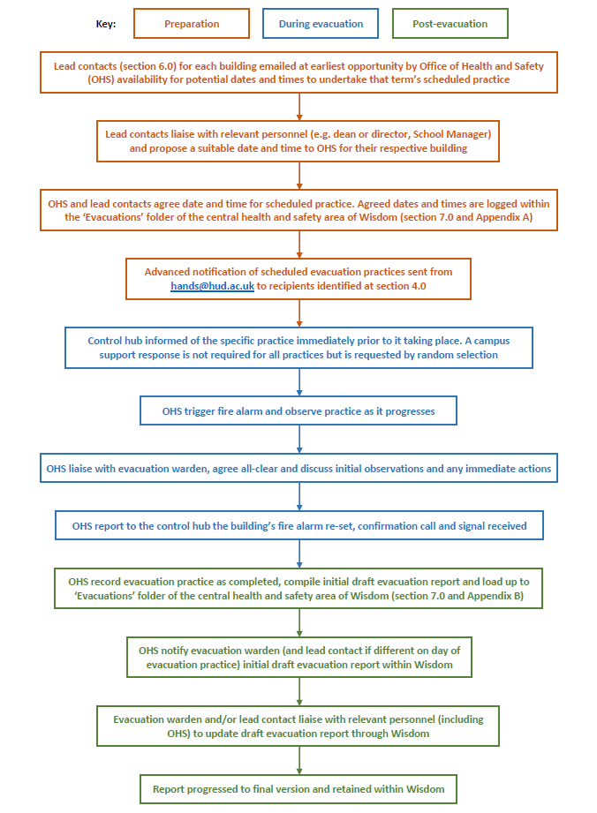
5.0 Practices – process flowchart

6.0 Buildings and lead contacts
Building | Lead contact(s)
3M BIC | Sally Connelly and Janine Downs
Atkinson Holt | Andy Bamforth
Barbara Hepworth Building | Stephen Calcutt and David Bentley
Charles Sikes Building | Emi Chiu and Business & Education Executive Support <bus-academicsupport@hud.ac.uk
Edith Key Building and Researcher Hub | Both buildings are currently mothballed
Harold Wilson Building | Damien Winterburn
Jo Cox More in Common Centre | Lee Felvus, Andrea Dalton and Muhammad Patel
Joseph Priestley East, South and West buildings | Natasha Reed
Journalism, Media and Film Building | Julian Schofield and David Bentley
Lockside and Haslett buildings | Emi Chiu, Business & Education Executive Support <bus-academicsupport@hud.ac.uk and Aurelie Whittaker
Oastler Building | Circulation list within Office of Health and Safety mailbox
Queen Street Building
Percy Shaw Building | David Bentley
Ramsden and Cockcroft buildings | Kevin Riley, Aurelie Whittaker and Natasha Reed
Richard Steinitz Building | David Bentley and Kevin Riley
Schwann Building | Circulation list within Office of Health and Safety mailbox
Sir John Ramsden Court | Joanne Ryan
Sir Patrick Stewart Building | Building currently mothballed
Spärck Jones Building | Darren Sugden and Aurelie Whittaker
Student Central | Circulation list within Office of Health and Safety mailbox
Technology Building | Martin Gargett, Aurelie Whittaker and David Bentley

7.0 Non-scheduled evacuations
Where buildings encounter an evacuation outside of a scheduled practice, these are primarily recorded through the daily security log administered at the university’s control hub.
These evacuations can occur during the during the normal ‘working’ day, early morning, at evenings or weekends. Building occupancy levels could be significant, those typically expected through to minimal. Situations that can trigger a non-scheduled evacuation include: -
- Fault with the building’s fire alarm system;
- Inadvertent activation caused by an activity;
- Malicious activation; and
- Genuine activation – whether manual or automatic - due to an unwanted fire situation.
Dependant on the nature and time of the fire alarm activation the resultant evacuation may be brought to the attention of OHS during or in the immediate aftermath (e.g. by the respective lead contact for the affected building, colleagues within Estates and Facilities) or following review of the security log by the university’s Security Manager.
The follow up reporting process for building evacuation practices does not apply to non-scheduled evacuations except where it is agreed between OHS and the respective building’s lead contact the non-scheduled evacuation can replace an impending scheduled practice or where that practice has yet to be scheduled. The primary criteria for a non-scheduled evacuation replacing a scheduled practice is that evacuation: -
- Occurred when the building had both a good level and representative occupancy;
- Proceeded well with the building’s procedures being successfully implemented; and
- Can be recorded in the reporting format of that for scheduled practices.
Where a non-scheduled evacuation replaces a scheduled practice OHS will record this within the respective report.
8.0 Evacuation reports – document management and retention
Individual reports are managed and retained within ‘Evacuation’ folder of the ‘Evacuation and Assembly Points’ sub-class of the ‘Central-Health-and-Safety’ class and ‘Health-and-Safety’ function of Wisdom:
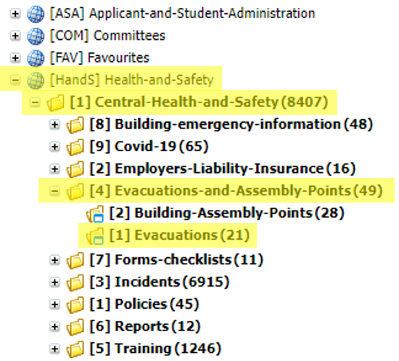
All reports attract a ‘5-plus-current-year’ retention period in accordance with the university’s document retention and disposal schedule.
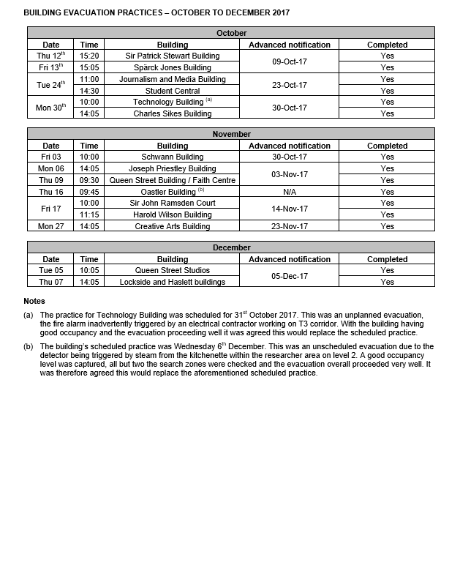
Appendix A: example log of building evacuation practices
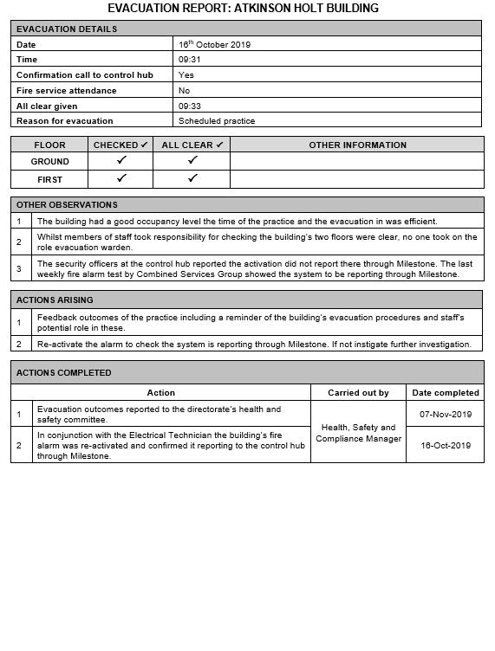
Appendix B: example building evacuation report

