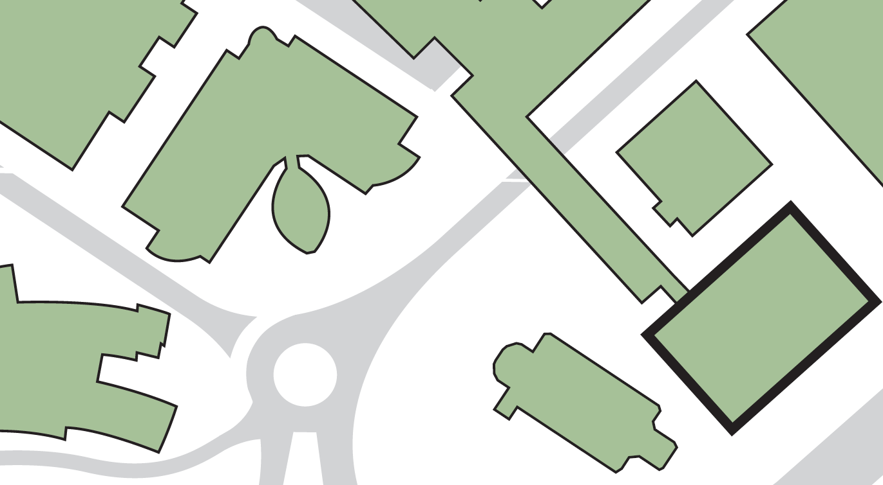

**Laura Annie Willson Building**

**Fire exit from level 3 across roof into Joseph Priestley South Building**

**4**

**4**

**Joseph Priestley (South) Building**

**Harold Wilson Building**

**Richard Steinitz Building**

**4**

**2**

**JOSEPH PRIESTLEY (WEST) BUILDING**

**1**

**3**

**St Paul’s Hall**

**Cockcroft Building**

**Exit opposite St Paul’s Hall**

**Fire exits from ground floor and corner staircase**

**3**

**2**

**Assembly point 14 (adjacent to Laura Annie Willson Building)**

**If evacuating the building by:**

**1**

**Main exit onto Queensgate ring road**

**BUILDING ASSEMBLY POINTS - JOSEPH PRIESTLEY (WEST) BUILDING**