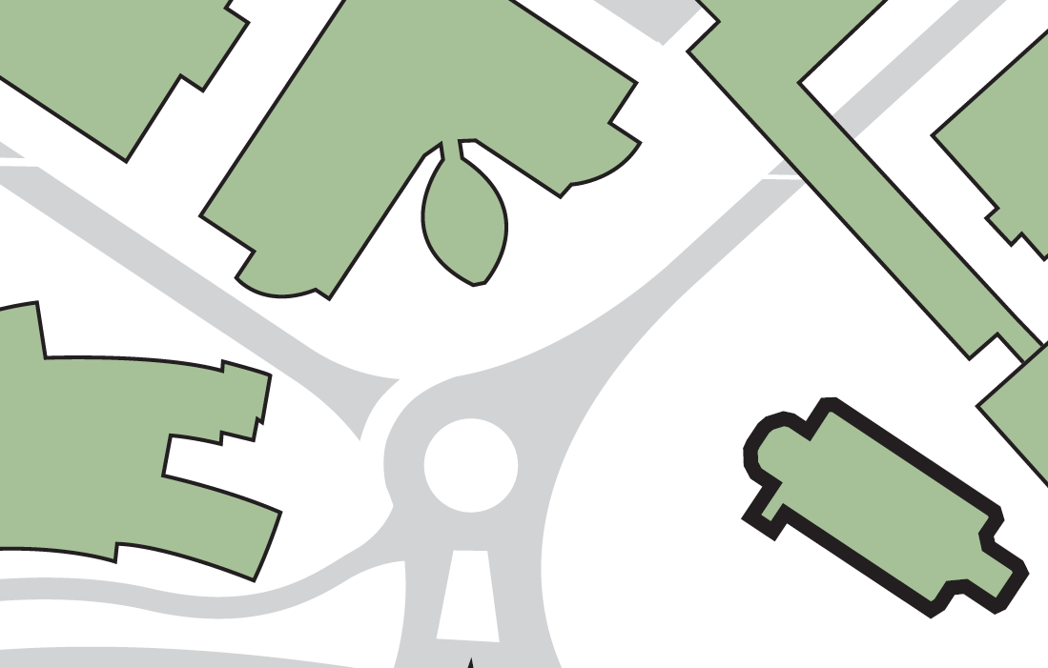

**Exit from main lobby area**

**1**

**2**

**Evacuating the building by:**

**Fire exit from main lobby area**

**3**

**Fire exit adjacent to stage, ring road side of hall**

**4**

**Fire exit adjacent to stage, Joseph Priestley Building side of hall**

**Laura Annie Willson Building**

**Joseph Priestley Building**

**Richard Steinitz Building**

**3**

**2**

**4**

**1**

**Assembly point 14 (University Square adjacent to Laura Annie Willson Building)**

**ST PAUL’S HALL**

**Harold Wilson Building**

**ASSEMBLY POINT LOCATION – ST PAUL’S HALL**