ASSEMBLY POINT LOCATION – CHARLES SIKES BUILDING
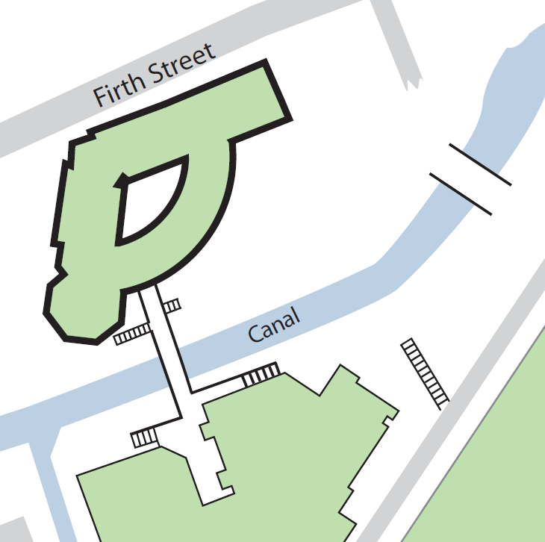
Schwann Building

CHARLES SIKES BUILDING

Assembly point 7 (area on the footpath between canal and Schwann Building)

Exiting the building by: -
Its exits and fire exits onto the bridge.
Its ground floor main exit.
Fire exits from the building’s staircases.
Fire exits from the Diamond Jubilee Lecture Theatre

