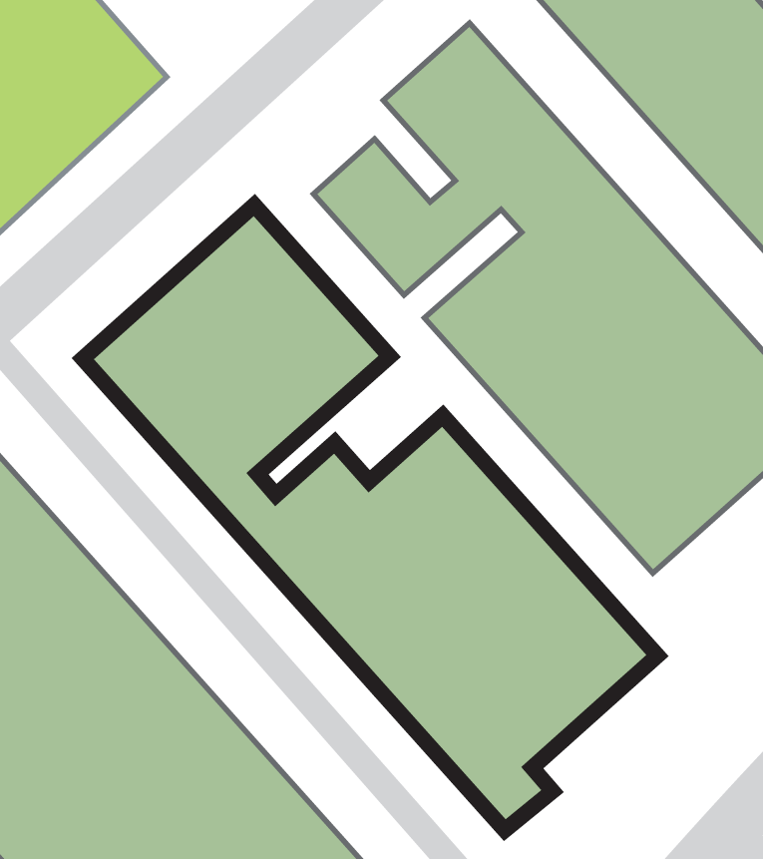

*Version: August 2016*

**Fire exit adjacent at top corner of building adjacent to Studio 1**

➐

**Fire exit from Studio 3, ground floor workshop and bottom of staircase from PS3 offices and teaching rooms**

➏

**Fire exit at bottom of staircase from balcony overlooking Studio 2**

➎

**Fire exit from Studio 2**

➍

**Fire exit from ground floor staff offices and Studio 2**

➌

**Fire exit onto Page Street - bottom of spiral staircase**

➋

**The building’s main exit**

➊

**Evacuating the building by: -**

**ASSEMBLY POINT 12 (AREA ADJACENT TO QUEEN STREET BUILDING)**

➐

***Page Street***

**Ramsden Building**

**Faith Centre**

**Queen Street Building**

**SIR PATRICK STEWART BUILDING**

➏

➎

➍

➌

➋

➊

**ASSEMBLY POINT LOCATION – SIR PATRICK STEWART BUILDING**