**1**

**1**

**Student Central**



**SIR JOHN RAMSDEN COURT**

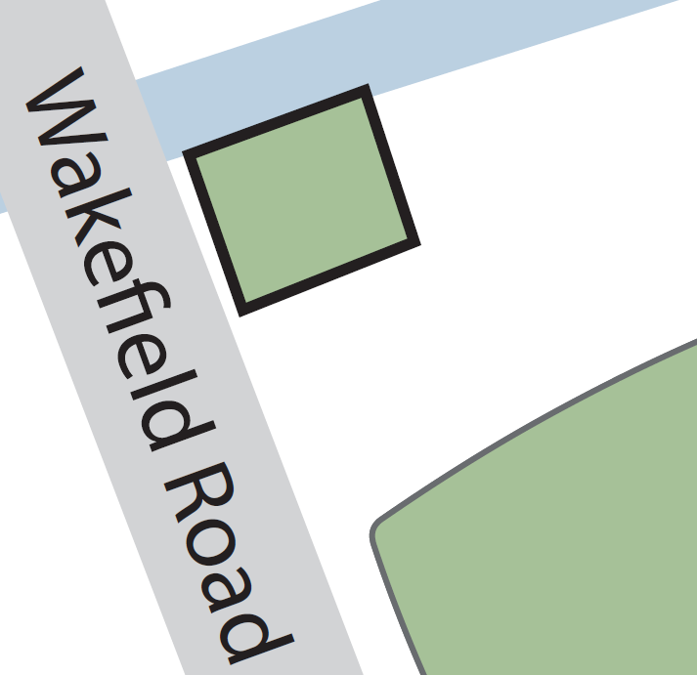

**Evacuating the building by its main exit**

**Assembly point 5 – Wakefield Road car park**

**BUILDING ASSEMBLY POINT LOCATION – SIR JOHN RAMSDEN COURT**