****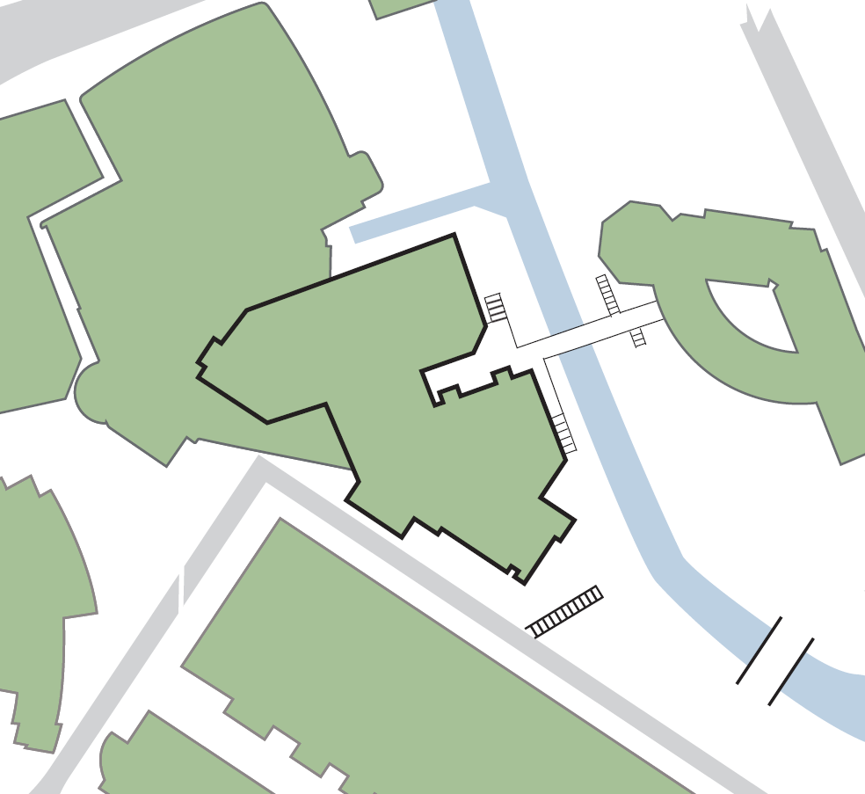

**Laura Annie Willson Building**

**Exit adjacent to DIGS Accommodation Office and fire exit from 24-hour PC facility**

**9**

**8**

**Fire exit at level 1 next to external steps to Laura Annie Willson Building**

**Exit from level 1 underneath bridge to Charles Sikes Building**

**7**

**Exit from Holocaust Exhibition and Learning Centre and fire exit from library level 2**

**6**

**Exit from Heritage Quay and fire exit from library level 3**

**5**

**Exit from atrium at level 4 onto external steps**

**4**

**Assembly point 6 (car park adjacent to Charles Sikes Building)**

**Exit onto Wakefield Road car park**

**3**

**Fire exits under Student Central from: service corridor; levels 3, 5 and 6 of library and McClelland Suite**

**2**

**Assembly point 5 (Wakefield Road car park)**

**Exit and fire exit onto University Square from atrium at level 4**

**1**

**Assembly point 2 (between Richard Steinitz and Oastler buildings)**

**1**

**ASSEMBLY POINT LOCATIONS SCHWANN BUILDING**

**SCHWANN BUILDING**

**8**

**9**

**6**

**5**

**5**

**7**

**4**

**3**

**2**

**Richard Steinitz Building**

**Student Central**

**SCHWANN BUILDING**

**Oastler Building**

**Charles Sikes Building**